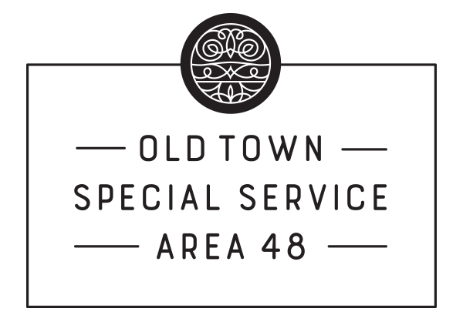
SSA 48 Old Town –Special Commission Meeting
Teleconference--COVID-19
Thursday, June 4, 2020
1:00pm

AGENDA
Commissioners and Staff Present: Ian M Tobin - Executive Director, Rachel Rubinson, Marketing and Membership Coordinator, Peter O’Brien, Mark Proesel, Don Klugman, Caroline Schoenberger, Judy Erwin, and Alex Christenson
Guests Present: Jennifer Tremblay

- Call to Order
The meeting was called to order at 1:08pm by Peter O’Brien.
- Roll Call
Quorum
- Introduction of Guests:
Jennifer Tremblay
- Review of DRAFT MINUTES from SSA 48 Commission Meeting on 04/22/2020
  - MOTION TO APPROVE 04/22/20 SSA 48 Commission Meeting Minutes by Ms. Erwin. Seconded by Ms. Schoenberger. The motion carries.

- Financial Report
Mr. Proesel reported on the SSA #48 Old Town Financials as of March 31, 2020. Mr. Proesel stated current expenditures would be similar to numbers reported in April. Mr. Proesel stated current accounts contained
$262,817.35

- Committee Reports

  - Executive Committee – Mr. Peter O’Brien, Chairman
    - Discussion on SSA 48 Old Town Response to COVID-19
Mr. Tobin detailed the OTMRA and SSA response to COVID-19 including rebates, programs, and resources.
    - Discussion on George Floyd Protests
Mr. Tobin detailed the circumstances that led to an emergency Commission meeting: looting in addition to lost revenue from COVID-19. Mr. Tobin noted he was optimistic that looting would not continue into next weekend, but stated AGB would have a presence in Old Town this weekend in case looting continued.
    - Discussion on Modified 2020 Budget and Workplan
Mr. Tobin discussed the rebate programs created to help offset unexpected costs incurred by Old Town businesses: Online Sales Investment, Health & Sanitation, Boarding-Up Services, and Vandalism Repair. Mr. Tobin noted the money for these rebate programs would be reallocated within the current 2020 budget. No funds would be pulled from essential services, only non-essential or over-budgeted items.
Mr. Tobin explained each rebate program would have a different application process but would function in essentially the same way, and each application would be reviewed on a case-by-case basis and go through an approval process before funds were dispersed. If there are more applications than funds available, a lottery will be conducted to disperse funds. Businesses can apply for rebates on a first-come, first-serve basis at the beginning of each month, to cover unexpected costs incurred beginning in March. All rebates are one-time payments.
Mr. Proesel asked for clarification regarding how frequently businesses can apply for funding. Mr. Tobin clarified businesses can apply for the same rebate in two consecutive months but wouldn’t automatically receive funding for both months.
Mr. Klugman expressed concern that allocated monies would overlap and businesses would take advantage of the funds. Mr. Tobin clarified each application would be reviewed and prior funds received would be considered before funds were dispersed.
      - MOTION TO APPROVE Modified 2020 Budget and Workplan by Mr. Proesel, seconded by Mr. Christenson. Motion carries.
    - Discussion on Vandalism Repair Rebate Program
Mr. Tobin stated the Vandalism Repair rebate would help businesses repair broken windows, or doors on their property as a result of looting. Businesses can apply for up to 50% of eligible costs, not to exceed $400.
        - MOTION TO APPROVE Vandalism Repair Rebate Program by Mr. Klugman; seconded by Mr. Proesel. Motion carries.
    - Discussion on Boarding-Up Services Rebate Program
Mr. Tobin stated the Boarding-Up Services rebate would help subsidize the cost of materials and labor needed for the protection of their business. Businesses can apply for up to 40% of eligible costs, not to exceed $500.
        - MOTION TO APPROVE Boarding-Up Services Rebate Program by Ms. Schoenberger, seconded by Ms. Erwin. Motion carries.

  - Residential Committee – Mr. Mark Proesel, Committee Chair
    - Discussion on Health & Sanitation Rebate Program
Mr. Tobin stated the Health & Sanitation rebate would help subsidize the cost of items needed for businesses to safely open and protect customers. Businesses can apply for up to 50% of eligible costs, not to exceed $400.
      - MOTION TO APPROVE Health & Sanitation Rebate Program by Mr. Proesel; seconded by Mr. Christenson. Motion Carries.
  - Communications Committee – Mr. Don Klugman, Committee Chair
    - Discussion on Online Sales Investment Rebate Program
Mr. Tobin stated the Online Sales Investment rebate would help businesses shifting to online sales. Businesses can apply for up to 30% of eligible costs, not to exceed $500.
      - MOTION TO APPROVE Online Sales Investment Rebate Program by Mr. Klugman. Seconded by Mr. Proesel. Motion carries.

- New Business
Mr. O’Brien thanked the Commissioners and the OTMRA team for their hard work.
Ms. Schoenberger asked if a partial or full closure of Wells street to accommodate outdoor dining would be possible. Mr. Tobin noted the street closure program is currently in a pilot stage, and is not yet taking applications for street closures throughout Chicago.

- Adjournment
Mr. Klugman made a motion to adjourn and was seconded by Ms. Erwin. The motion carries and the meeting was adjourned at 2:13pm.

