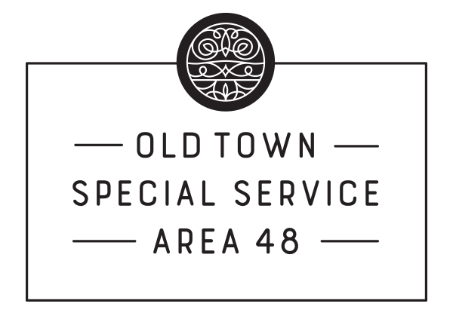
SSA 48 Old Town –Commission Meeting
Teleconference--COVID-19
Wednesday, April 22, 2020
5:30pm

AGENDA
Commissioners and Staff Present: Ian M Tobin - Executive Director, Sam Waldorf, Associate Director, Rachel Rubinson, Marketing and Membership Coordinator, Peter O’Brien, Mark Proesel, Don Klugman, Caroline Schoenberger, and Alex Christenson
Guests Present: Joy Coombes Eilts & Associates, and Steve Golyzniak Tovar

- Call to Order
The meeting was called to order at 5:35pm by Peter O’Brien.
- Roll Call
Quorum
- Introduction of Guests:
Joy Coombes and Steve Golyniak
- Review of DRAFT MINUTES from SSA 48 Commission Meeting on 01/15/2020
  - MOTION TO APPROVE 01/15/20 SSA 48 Commission Meeting Minutes Ms. Shoenberger. Seconded by Ms. Erwin. The motion carries.

- Financial Report
Mr. Proesel reported on the SSA #48 Old Town Financials as of March 31, 2020.
Present Balance: $329,225.98
Revenue to date: $258,139.47
Expenses in 2020 includes the following:
Advertising and Promotion: $600
Operations & Administrative Support: $747.62
Public Way Maintenance: $61,440.60
Parking/Transit/Accessibility: $1,560
Safety Programs: $21,198.20
Total Expenses: $85,546.42
Net Position: $174,593.05
- Committee Reports

  - Executive Committee – Mr. Peter O’Brien, Chairman
    - Discussion on SSA 48 Old Town Response to COVID-19
Mr. Tobin discussed how Old Town is managing the COVID-19 crisis: adjusted hours of the private security team, pressure washing sidewalks, assisting businesses, and creating a plan for long-term recovery. Mr. Tobin noted that the updated private security hours are now Friday and Saturday from 7pm – 12am, to accommodate increased food delivery and curbside pickup. He also noted the OTMRA will be assisting businesses via rebates educational webinars to address business survival and recovery.
    - Discussion on SSA 48 2019 Audit: Eilts & Associates--Joy Coombes
Ms. Coombes discussed the 2019 SSA 48 audit. Ms. Coombes stated everything was “presented fairly” and there was nothing unusual in the budget. She noted SSA 48 stayed within budget guidelines. Ms. Coombes suggested the accounting policies and procedures should be reevaluated periodically, since they have not been updated since 2008. Additionally, Ms. Coombes noted the SSA audit deadline has been extended to May 15.
      - MOTION TO APPROVE 2019 Audit (6.02) by Mr. Klugman. Seconded by Mr. Lubbat. The motion carries.
  - Discussion on SSA 48 2019 Audit: Eilts & Associates--Joy Coombes
    - MOTION TO APPROVE Reimbursement of OTMRA for Administrative Expenses totaling $25,125.00 by Mr. Klugman. Seconded by Ms. Shoenberger. The motion carries.
Fees include:
Office Supplies: $500
Office Equipment: $500
Printing: $500
Postage: $125
Non-Service Personnel: $23,500

  - Public Way Committee – Mr. Dino Lubbat, Committee Member
    - Discussion on 2020 Landscaping Contract
      - MOTION TO APPROVE Landscaping Contract with Old Town Gardens totaling $51,066 for 2020 (2.02) by Ms. Erwin. Seconded by Ms. Shoenberger. The motion carries.
Mr. Lubbat presented the landscaping contract from Old Town Gardens. Mr. Lubbat noted the holiday decorations section was not part of the contract.
    - Discussion on COVID-19 Pressure Washing Contract
Mr. Lubbat discussed the option to spray disinfectant as part of the pressure washing contract. Mr. Lubbat stated the disinfectant would not last long and was not proven to be effective in fighting COVID-19. Mr. Lubbat therefore did not recommend the SSA pursue this option.
      - MOTION TO APPROVE COVID-19 Quality Pressure Washing totaling $8,250 (2.12) by Mr. Christenson. Seconded by Ms. Shoenberger. The motion carries.
    - Discussion on 2019-2020 Season Snow Removal Service Recap: Steve Golyzniak of Tovar
Mr. Golyzniak provided a brief summary of the 2019-2020 snow removal season. Mr. Golyzniak noted below-average snow totals and detailed Tovar’s preventative approach to clearing snow: crews on-site ahead of storms, starting at the perimeter of Old Town and working inward. Mr. Tobin commended Tovar for their overall performance, responsiveness, and preemptive approach to snow removal during the 2019-2020 season.

  - Residential Committee – Mr. Mark Proesel, Committee Chair
    - Discussion of Contract for Security Service Update: AGB--Capt. Kevin Salmon
Mr. Proesel talked about changes to the security service hours. Starting May 1, AGB will be in Old Town from 6pm-12am Friday and Saturday nights, with an additional 4 hours staggered 3 times throughout the week. Mr. Christenson suggested reducing AGB hours during COVID-19, since there was reduced traffic on the streets. Ms. Shoenberger suggested re-allocating the hours from April to June if the AGB contract mandated a minimum number of hours. The Residential Committee will review these suggestions.
  - Communications Committee – Mr. Don Klugman, Committee Chair
    - Discussion on Digital Promotion Rebate Program
Mr. Klugman offered the efforts of the Communications Committee to any initiative that requires visual or audio support.
      - MOTION TO DIRECT the Sole Service Provider to create a Digital Promotion Rebate Program not to exceed $5,000 (1.06) by Mr. Klugman. Seconded by Mr. Lubbat. The motion carries.
Mr. Tobin summarized the new digital rebate program. This program would offer rebates offseting up to 50% of eligible costs (not to exceed $400 per recipient) for digital promotions, digital marketing consultants, or programs or subscriptions purchased online. Businesses transitioning to online shopping or promotion would be eligible to receive a rebate. Recruitment for this program will be done by the OTMRA.

- New Business
Mr. O’Brien reminded commissioners their ethics statements are due May 1 (for the county) and June 1 (for the city.
Mr. Tobin briefly introduced the new OTMRA Marketing and Membership Coordinator, Rachel Rubinson.
Ms. Shoenberger asked for the committee to encourage coworkers, friends, and family to complete the census.

- Adjournment
Ms. Erwin made a motion to adjourn and was seconded by Mr. Klugman. The motion carries and the meeting was adjourned at 6:42pm.

