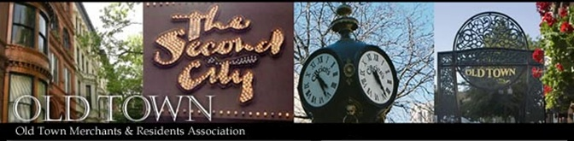2016 Membership Application - Resident
Thank you for your continued support and involvement with OTMRA. Please fill out the following 2016 resident membership application in full and submit with payment. This membership is valid through January 31st, 2017.
Note(s): It is organizational policy to keep private the names and personal contact information of members
1520 N. Wells – Lower Level • Chicago, IL 60610 • 312-951-6106(p) • 312-951-9427(f) • otmra@oldtownchicago.org
Please select a payment method:
All applications (including payment) should be mailed to:
OTMRA, 1520 N. Wells – Lower Level, Chicago, IL 60610 or faxed to 312-951-9427 or emailed to otmra@oldtownchicago.org

 Check or Money Order (UMake payable toU: Old Town Merchants & Residents Association)
 PayPal Online (VisitU www.oldtownchicago.org/membership to pay online)
 Credit Card (you MUST fill out all the information below):   
Name (on card) ____________________________________Card Number ________________________________ Exp. Date _________
Billing Address _________________________________________ City _______________ State _________ Zip ____________________
Credit Card #_________________________________________ Exp _____/_____ CCID (code on back of card) ___________________
Resident Membership Information:

Please check box: Residential, 1-year – $50
Resident Name(s) _____________________________________________________________________
Home Address __________________________________________________________ Zip __________
Preferred Phone Number__________________ Preferred E-mail ______________________________
Favorite Old Town Businesses (Past or Present) ______________________________________________
What are your Thoughts on Old Town (in 25 words or less)? ____________________________________
______________________________________________________________________________
______________________________________________________________________________
______________________________________________________________________________
Content Contributors are creative Old Town resident members who will be tasked with producing original articles, reviews, photos or videos for use on the website to supplement our own efforts.
Are you interested in serving as a Content Contributor for the Old Town website?  Yes  No
Historians will be asked to occasionally provide editorials or articles about the history of Old Town for online/print.
Are you interested in serving as an Historian?  Yes  No

