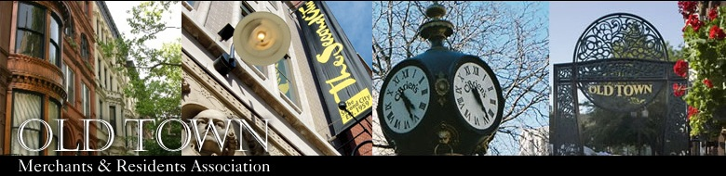2016 Membership Application – Business / NFP
Please fill out the following 2016 business membership application in full.

The 2016 business membership is valid through January 31, 2017.
Business Membership Options:

Check one:  Business, 1-year – $200  Non-Profit, 1-year -- $100
Please note that only bolded information can appear in public listings:
Business Name(s) ____________________________________________________________________
Main Contact Name/Title ______________________________________________________________
Business Address ______________________________________________________ Zip __________
Business Phone _____________________________ Business Fax _____________________________
Main Contact Email ________________________________ Website ___________________________
Twitter Handle @__________________ Facebook Name ____________________________________
Business Description (max. 300 characters) _______________________________________________
____________________________________________________________________________________
____________________________________________________________________________________
____________________________________________________________________________________
Business Type(s) __________________ Date Business Started _________ Number of Employees ____

Note(s): Public listings consist of Business Name, Address, Phone, Fax and Website. It is organizational policy to keep private the names and personal contact information of members.
Please select a payment method:
All applications (including payment) should be mailed to:
OTMRA, 1520 N. Wells – Lower Level, Chicago, IL 60610 or faxed to 312-951-9427 or emailed to otmra@oldtownchicago.org

 Check (UMake payable toU: Old Town Merchants & Residents Association)
 PayPal Online (VisitU www.oldtownchicago.org/membership to pay online)
 Credit Card (you MUST fill out all the information below):   
Name (on card) ____________________________________Card Number ________________________________ Exp. Date __________
Billing Address _________________________________________ City _______________ State _________ Zip ____________________
Credit Card #_________________________________________ Exp _____/_____ CCID (code on back of card) ___________________

1520 N. Wells – Lower Level, Chicago, IL 60610 • 312-951-6106(p) • 312-951-9427(f) • otmra@oldtownchicago.org

